**Phase 5 project**

**CI/CD Deployment for Spring boot Application**

**OUPUTS:**

**Flow chart:**

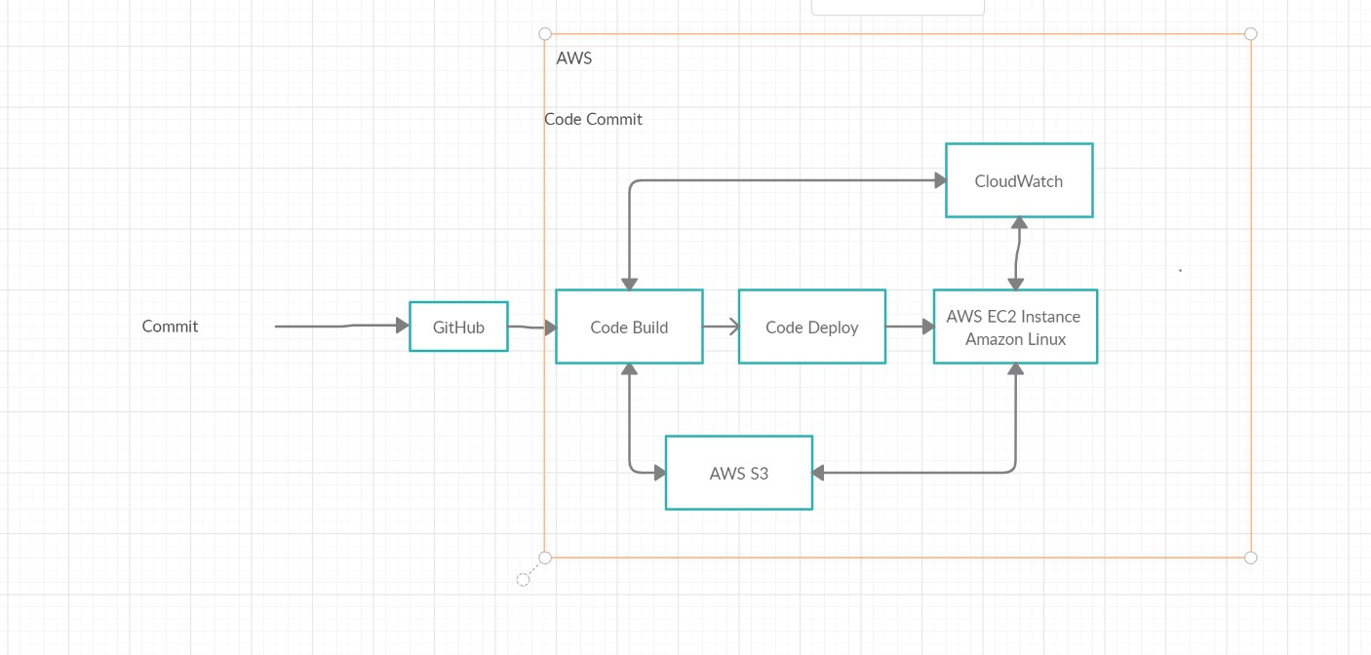

**Eclipse**

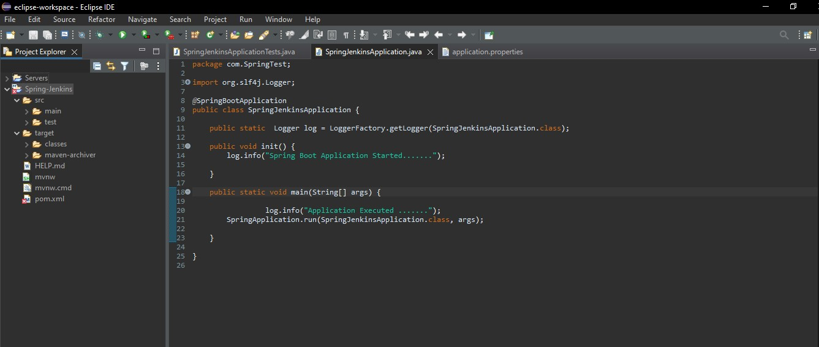

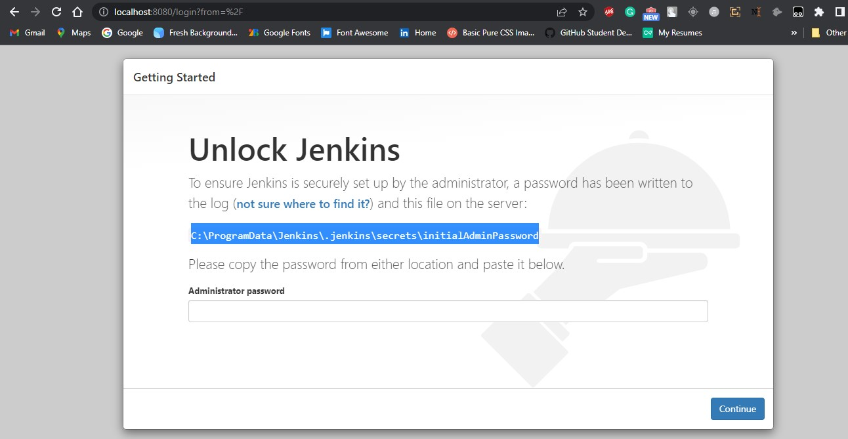

**1. I create Simple Spring boot Application to build a CI/CD pipeline to demonstrate continuous deployment:**

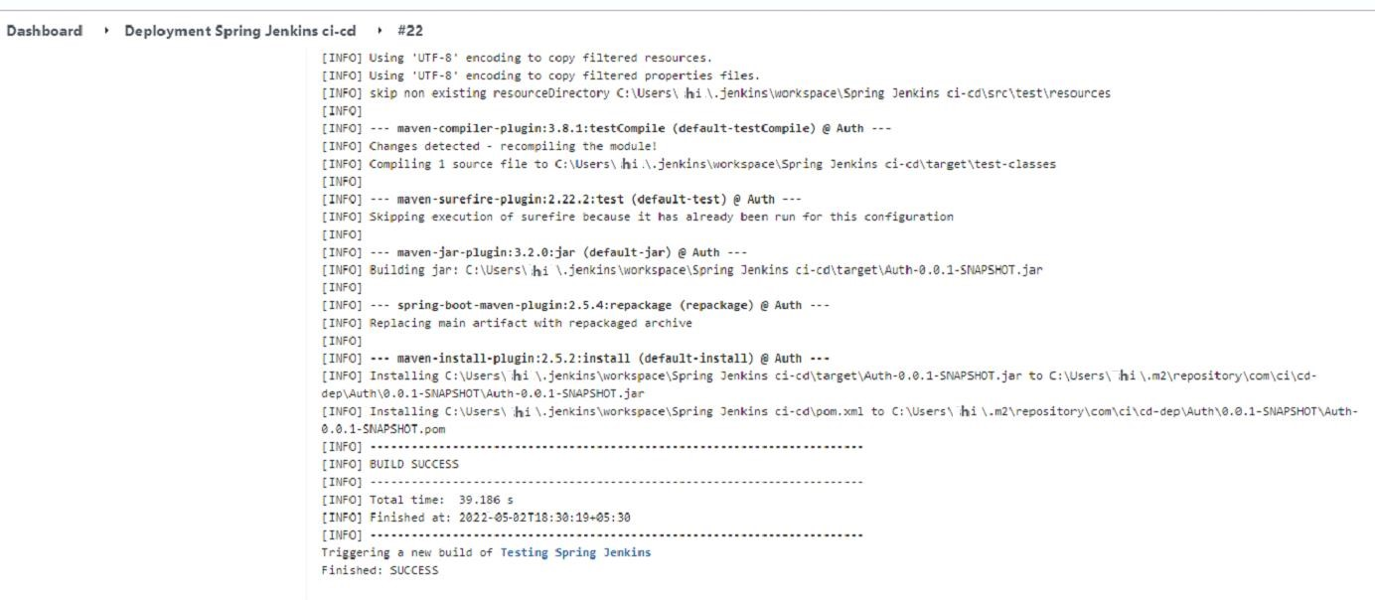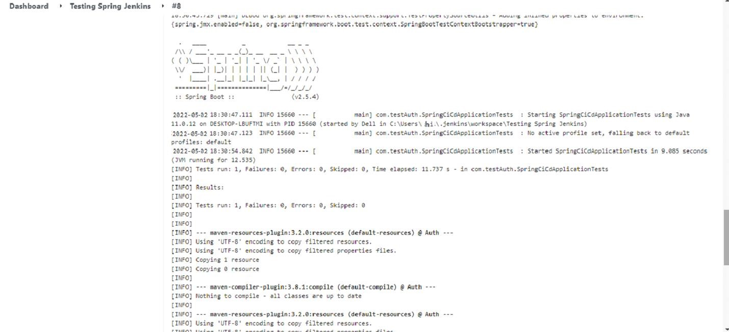

**Jenkins : Run Jenkins**

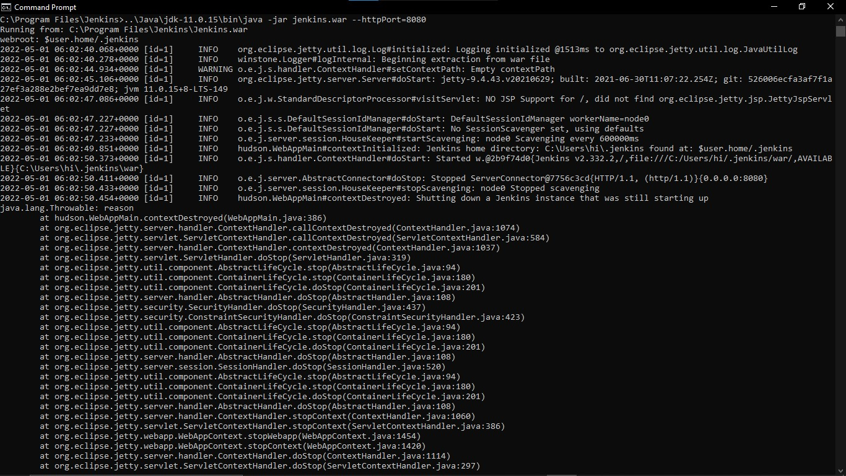

**CREATE THREE JENKINS PROJECT DEPLOYMENT:-**

**DEPLOYMENT-TESTING-PRODUCTION**

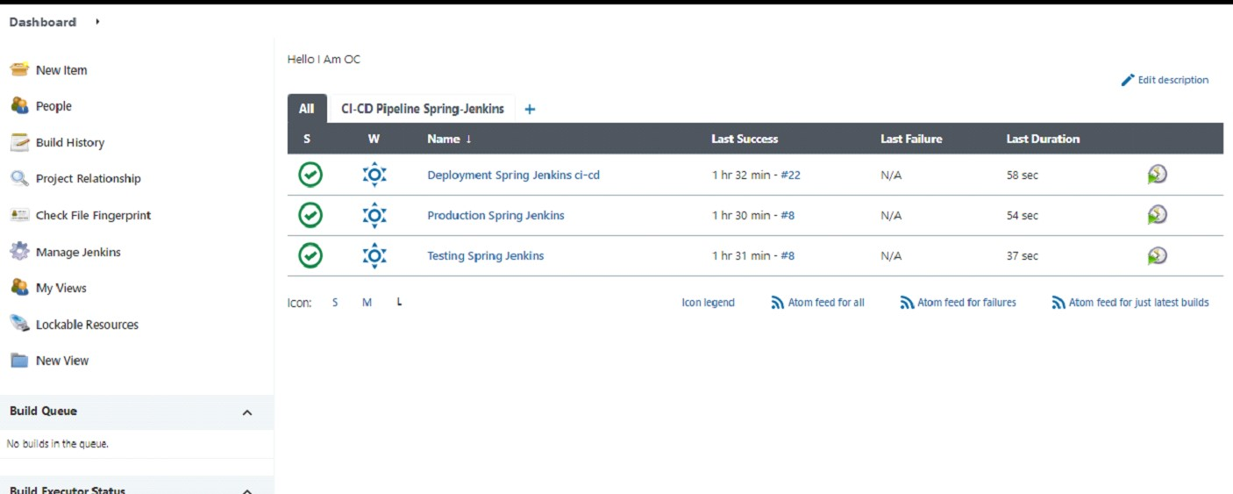



# Final Output:-

**Last host the application on AWS EC2 instance:**

